Advance User (Important ! Do not connection to Router Model if you are Advance Technical User)

Understand for the Reset Button / Router Button

Reset / Router Button is the same. When Power On the LED , hold reset button 4 second(Fast Flash), it will reset LED to default

See this video to Know how to Reset LED
https://youtu.be/Se-QBHoDHAI

Hold Reset Button for 12 to 14 Second, it will switch the LED to Router Mode. (First 8 second is Green Flashing Frequency, and then 8 to 14 second the LED indiciator will become Fast Green LED Flash 2 time, Off . And second Green LED Flash 2 time again, Off. Then release the Button

See this Video
https://youtu.be/QxaVy8mlwi8

It's Must Power On and immediately to Press the Button can work! Otherwise when you power on and hold the reset / router button will not work!

How to set for Router Model ?
Before SetUp Router Model, you Must Know how to Reset the LED firstly if setup fault!

1) Power On the LED Firstly
2) Press the Reset Button / Router Button immediately
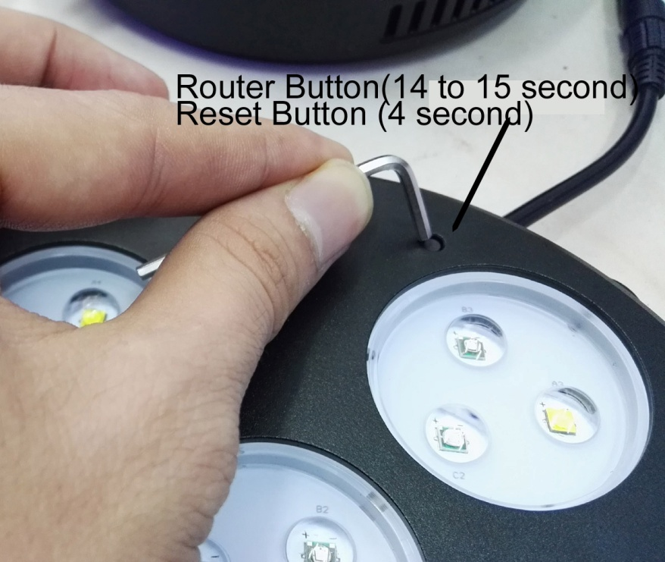
3) The Indicator LED will Flashing (Around 8 second green), and then waiting until the third time of Green Flashing (Around to 12- 14second) to release the reset button /Router button
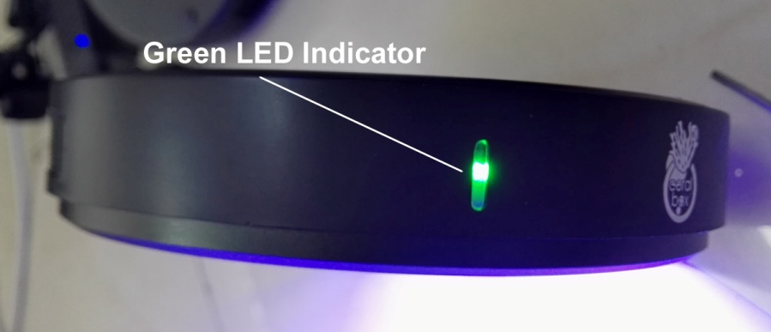

4) The LED indicator will turn Red flash 2 second
5) Open the apps, Join the Network firstly(Must using Apps Join Network, otherwise it will not work)
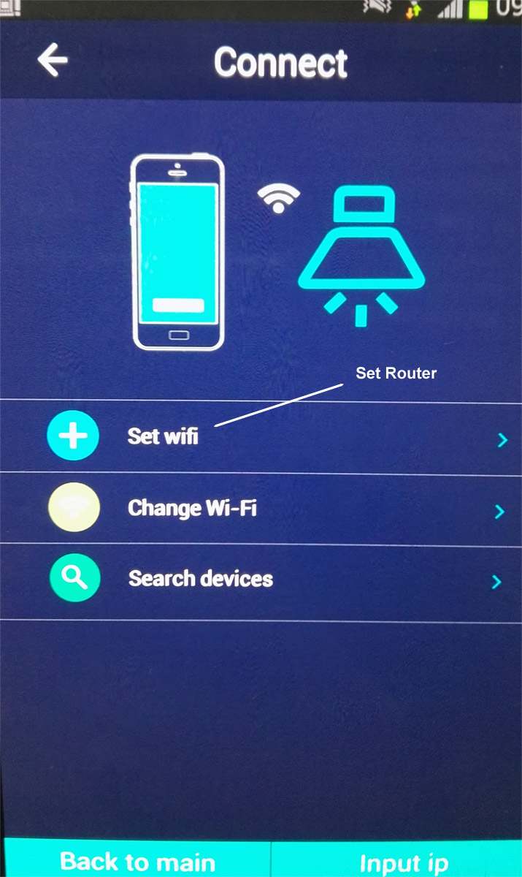

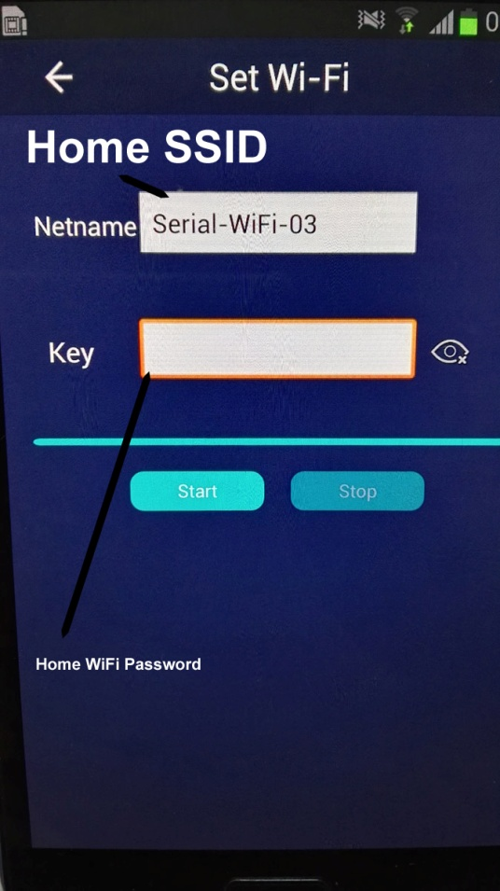

Important! For the Home SSID Start , do not press Stop on it. And try to press the screen within 20 second to prevent for your screen saver leave out the search screen. Its need to around 1 to 2 mins on the search for your SSID
_________________________________________________
6) In the apps search the Lamp and press it to connection

